Joaquin Murrieta ECV 13 Board (most) 1991
Front : Frits Fynaut (RIP), Ray Bonetti, Sandy Gold, Chuck Gavrilis (RIP) & Carter Wilson
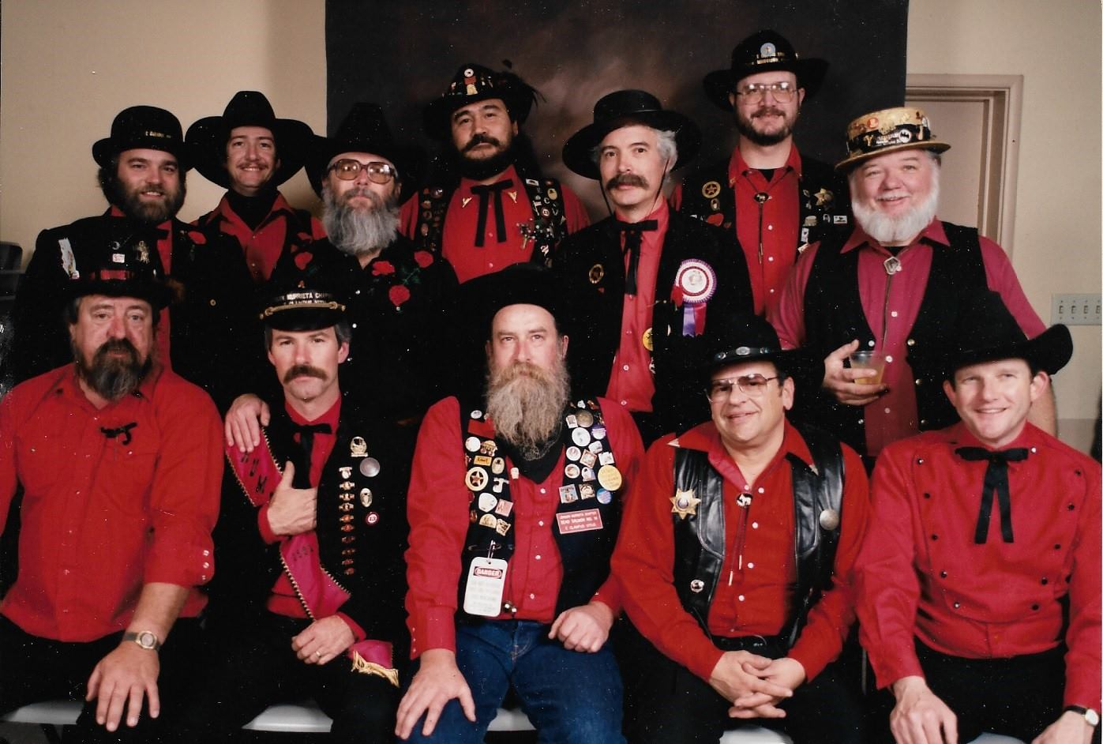
Back : Cake Johnson, Scott Jenny, Doug Kinsman, Bobby Cruz, Larry Mathewson, Eric Leonhardt & Fred Hansen (RIP)

