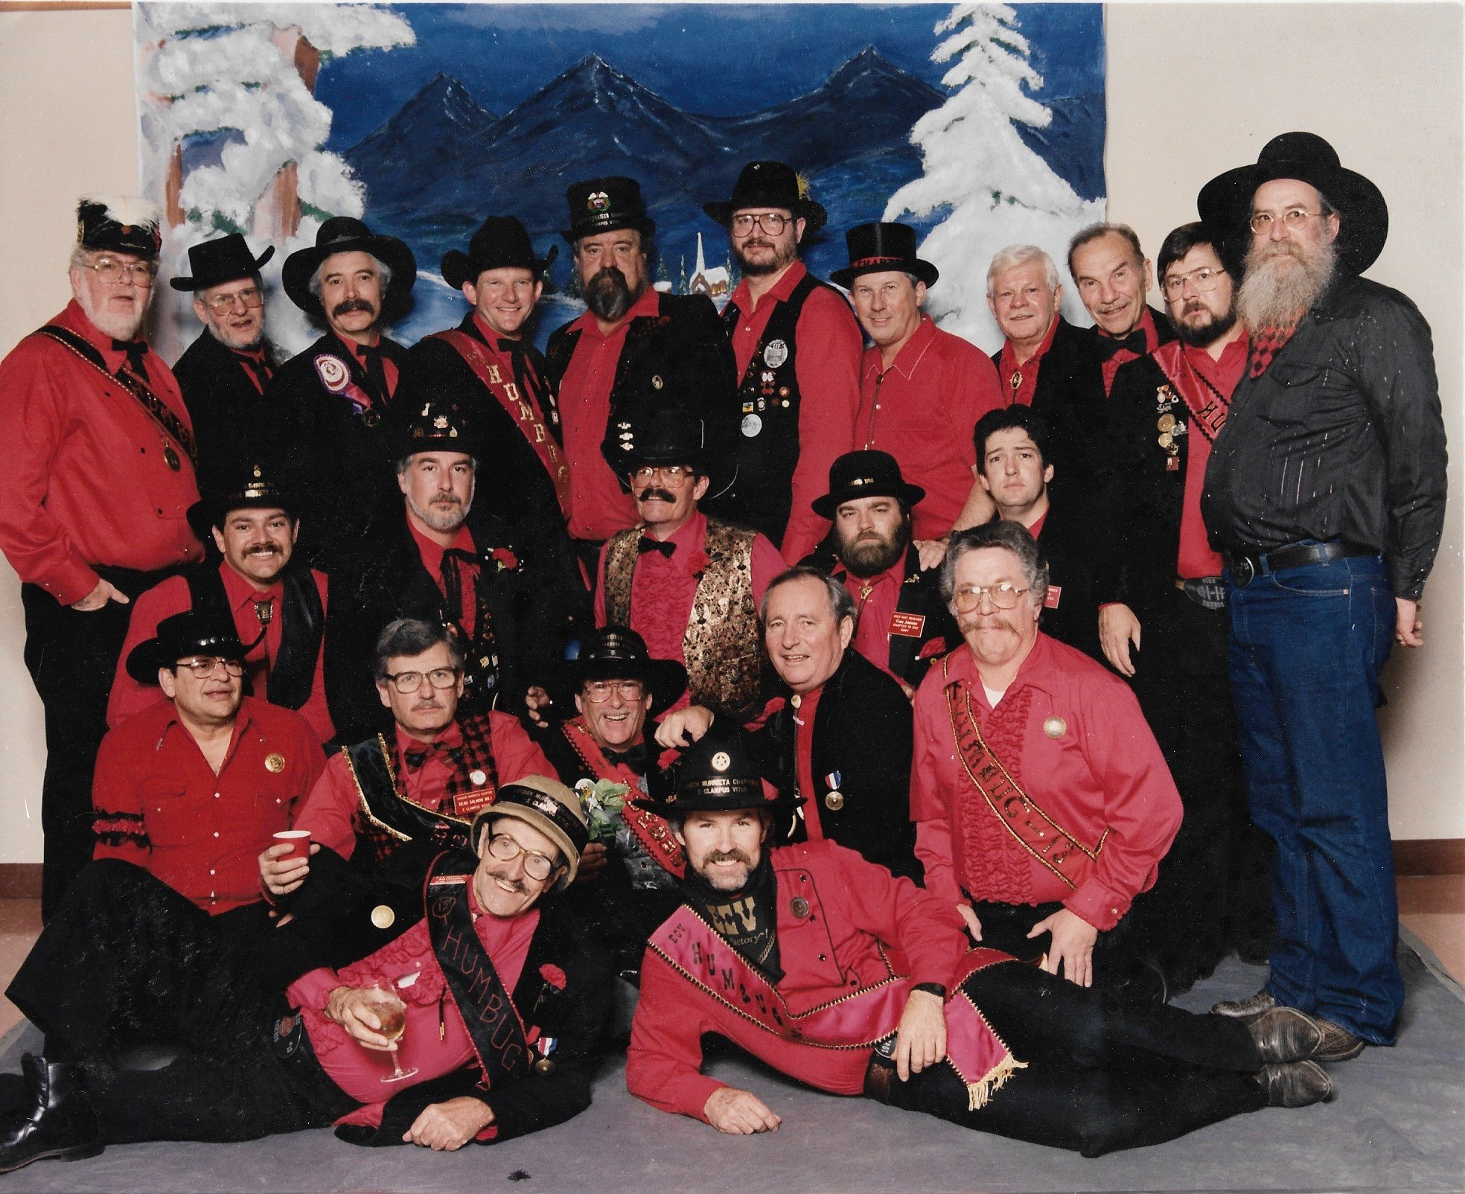

ECV 13 Board 1992
4th row: XSNGH C.W. Jones, Jerry Koran, XNGH Larry P. Mathewson, XNGH Carter Wilson, XNGH Frits Fynaut, Eric Leonhardt, Mike Moulton, XNGH Jim Ferris, XNGH Ken Roberts, XNGH Stan Elam, XNGH Sandy Gold.
3rd row: Lionel Luna, Zack Markham, XNGH Jon Wilson, XNGH Cake Johnson, XNGH Scott Jenny.
2nd row: XNGH Chuck Gavrilis, XNGH Alan Ramsay, XNGH Bill Walters, XNGH ECV 1 John Hard, XNGH "The Don" Kelso.
1st row: XSNGH Geno Fambrini, XNGH Ray Bonetti.

